**Day 4 | 23rd August 20 Assignment 20**

**\*Cyber security essentials by Letsupgrade**

**Name – MD WASIM ANSARI**

**Ph no – 7003571327**

**Email –** [**wasimm267@gmail.com**](mailto:wasimm267@gmail.com)

**1. Find out the mail servers of the following domain :**

**Ibm.com**

**Wipro.com**

**ANS. For that we need to use Nslookup command**

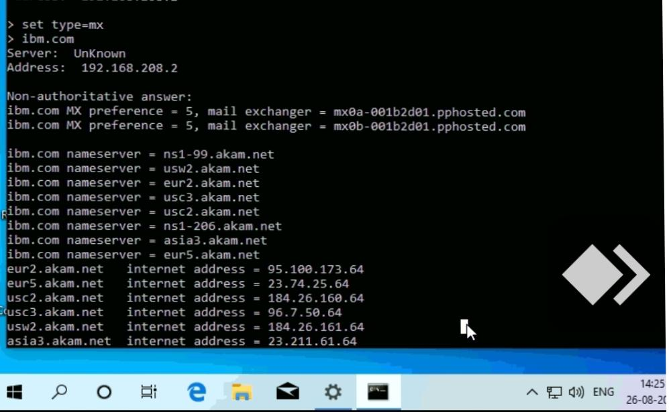

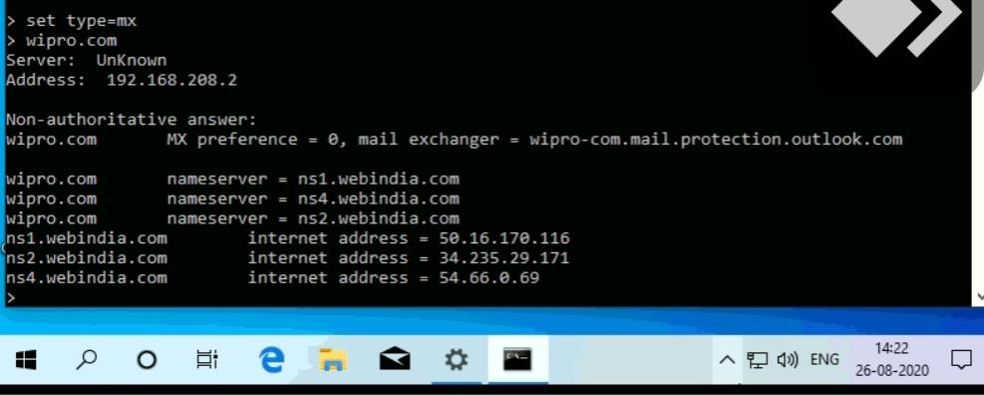

**2. Find the locations, where these email servers are hosted?**

**Ans.**

**Mail server of IBM and Wipro as shown in the screenshot are**

* **IBM**

|  |  |
| --- | --- |
| MX 1 | mx0a-001b2d01.pphosted.com |
| MX 2 | mx0b-001b2d01.pphosted.com |

* **Wipro**

|  |  |
| --- | --- |
| MX 1 | Wipro-com.mail.protection.outlook.com |

**Location are listed here \***

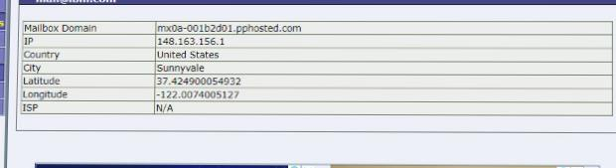

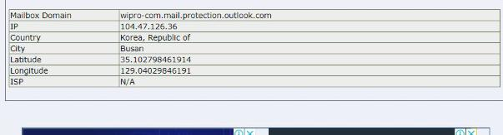

**3. Scan and find out port numbers open 203.163.246.23?**

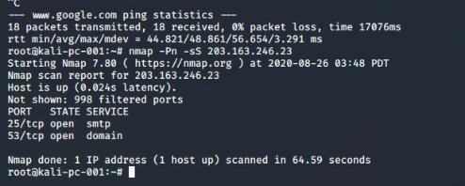**Ans. So here 25 and 53 ports are open and 998 are filtered which are not shown.**

**4. Install nessus in a VM and scan your laptop/desktop for CVE?**

**Ans.Here is the screenshot of my scanned Machine**

**Link to the report -** https://drive.google.com/file/d/1KyUIfPI9LaYdVoCyGCWZ9Q-BBUBMKaJm/view?usp=drivesdk

